**Ideation Phase**

**Define the Problem Statements**

|  |  |
| --- | --- |
| Date | 27 June 2025 |
| Team ID | LTVIP2025TMID60630 |
| Project Name | Traffictelligence: Advanced traffic volume estimation with Machine Learning |
| Maximum Marks | 2 Marks |

**Customer Problem Statement Template:**

Create a problem statement to understand your customer's point of view. The Customer Problem Statement template helps you focus on what matters to create experiences people will love.

A well-articulated customer problem statement allows you and your team to find the ideal solution for the challenges your customers face. Throughout the process, you’ll also be able to empathize with your customers, which helps you better understand how they perceive your product or service.

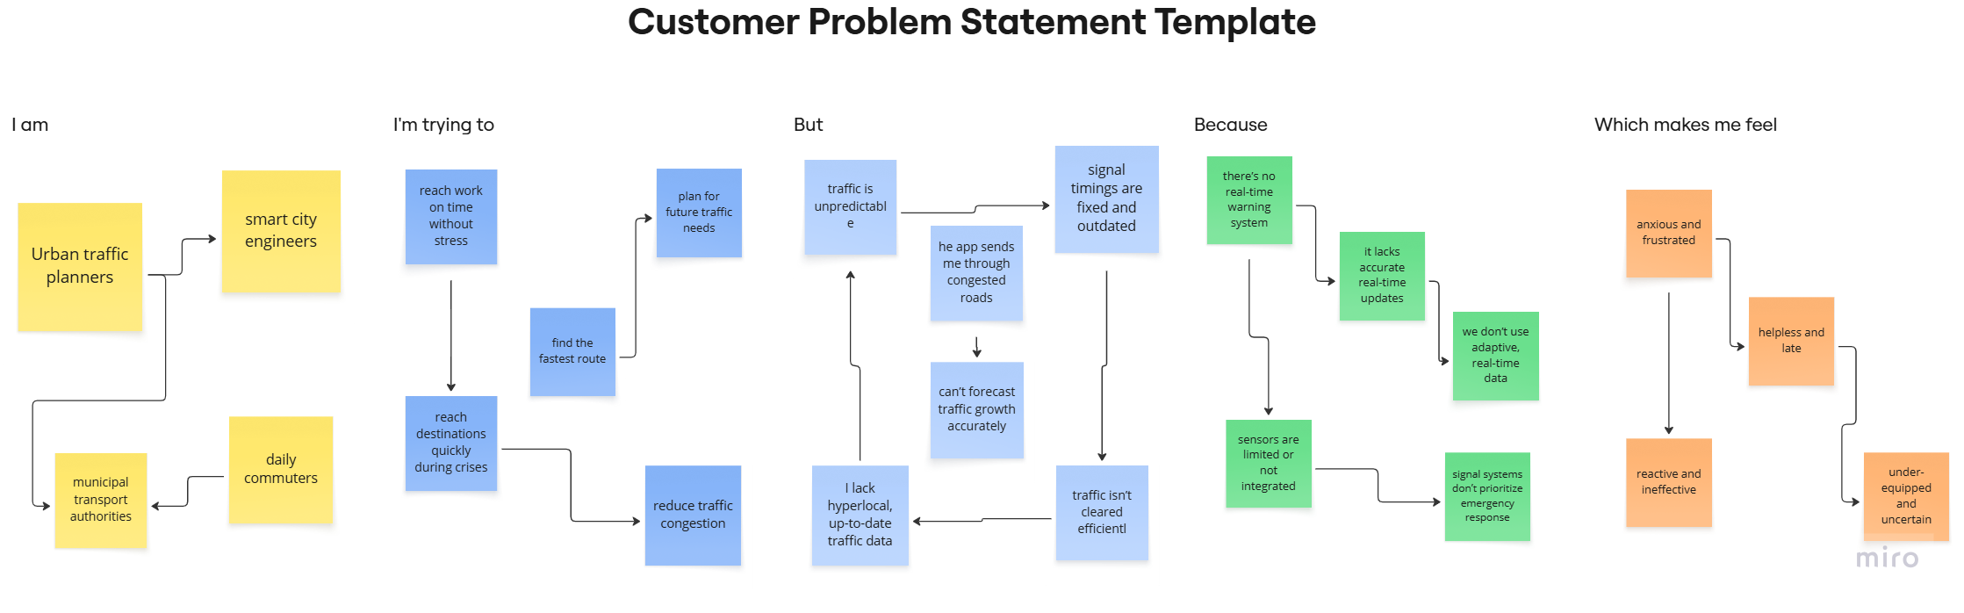

|  |  |  |  |  |  |
| --- | --- | --- | --- | --- | --- |
| **Problem Statement (PS)** | **I am (Customer)** | **I’m trying to** | **But** | **Because** | **Which makes me feel** |
| PS-1 | someone who relies on navigation apps | find the fastest route | the app sends me through congested roads | t lacks accurate real-time updates | helpless and late |
| PS-2 | designing infrastructure | make data-backed planning decisions | I lack hyperlocal, up-to-date traffic data | sensors are limited or not integrated | under-equipped and uncertain |